start_url = 'https://en.wikipedia.org/wiki/Yuri_Gagarin'**->** target_url = 'https://en.wikipedia.org/wiki/Yang_Liwei'

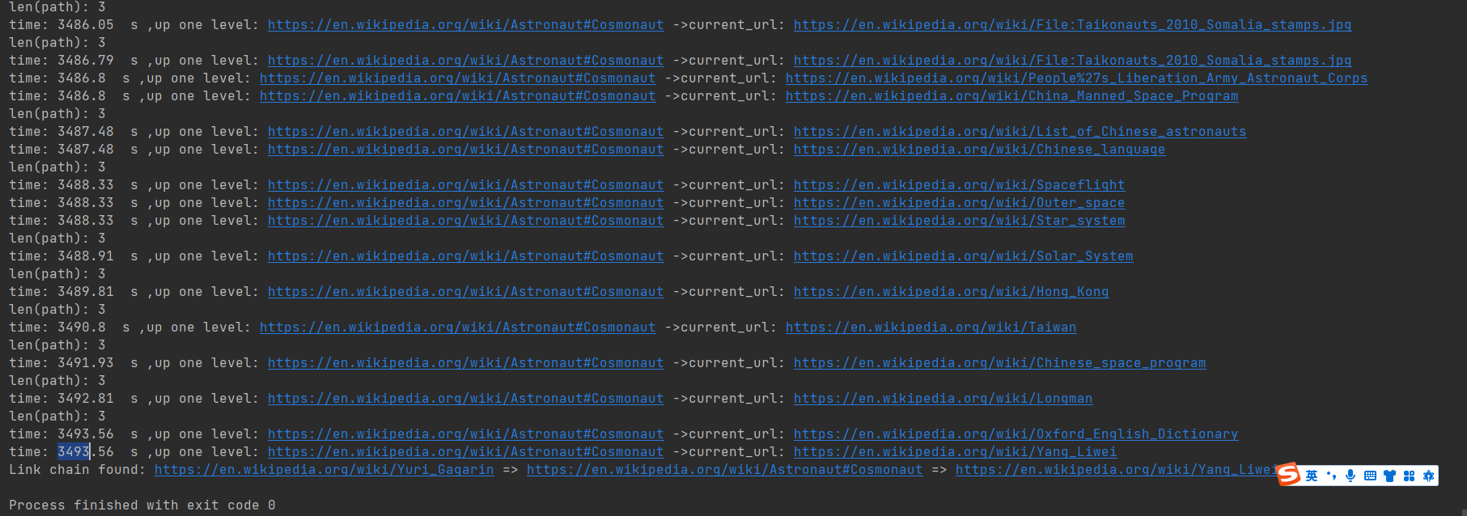

start_url = 'https://en.wikipedia.org/wiki/Yang_Liwei'**->** target_url = 'https://en.wikipedia.org/wiki/Yuri_Gagarin'

